Getting Dirty

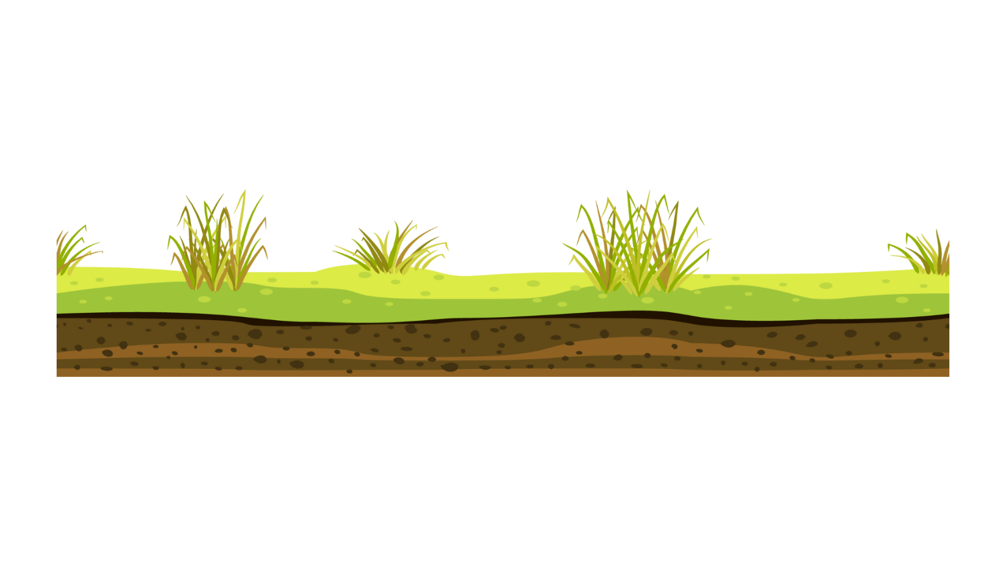

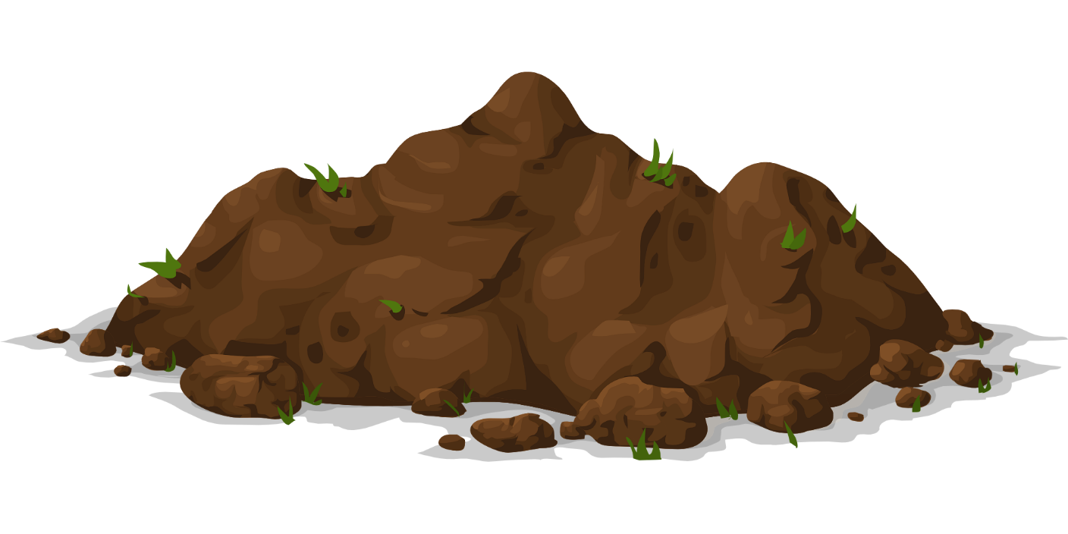

Dirt is all around us.

It is the top layer of our planet, Earth.

Dirt is also called soil.

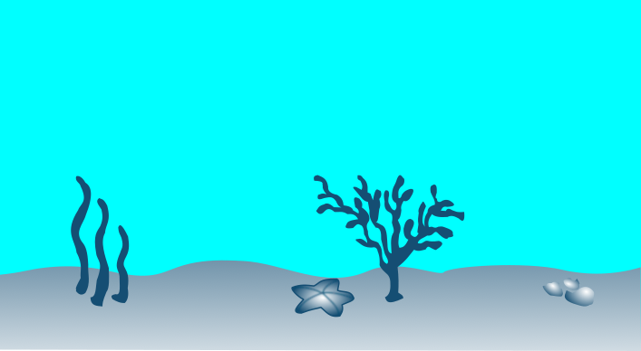
Soil is everywhere.

It is at the top of mountains.
It is at the bottom of the ocean.

Soil is under tall buildings and under your feet!
Not all soil is the same.

Soil has different colors and textures.
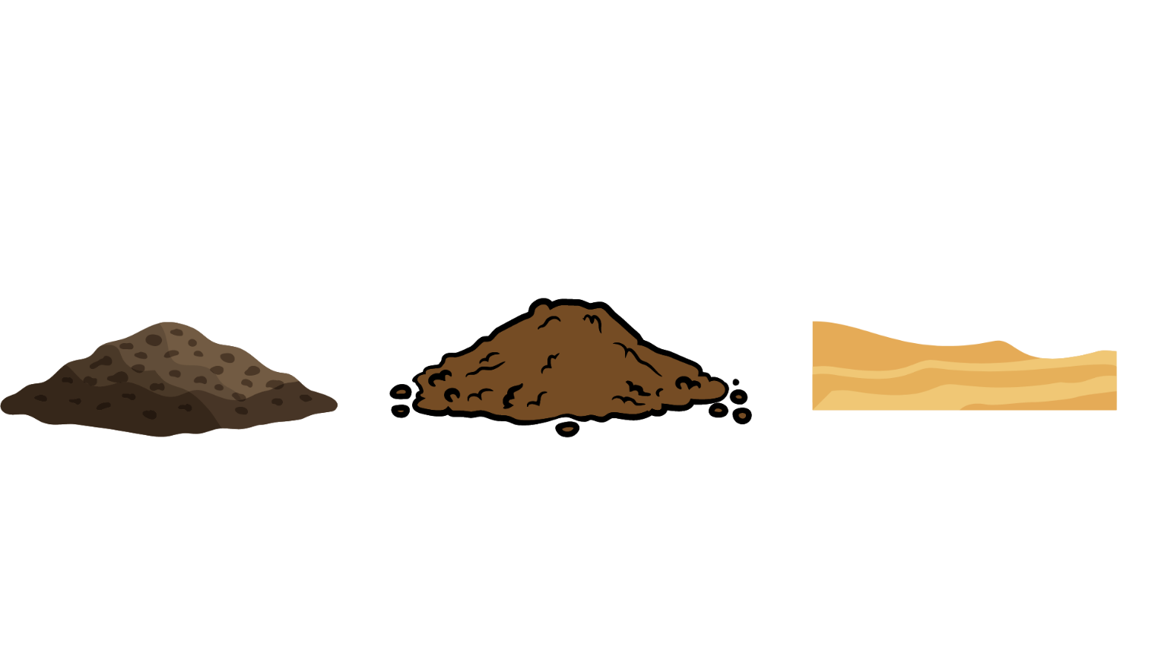
That is because different ingredients make up soil.

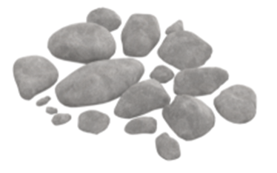
Soil has rocks. Some rocks are very small and others are large.

Sand is found in soil. Sand is broken rock.
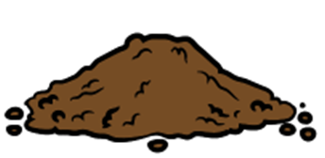
Some soils have clay.

Air and water are found in soil.
Living and once living things are also in the soil. There are plants and plant parts.

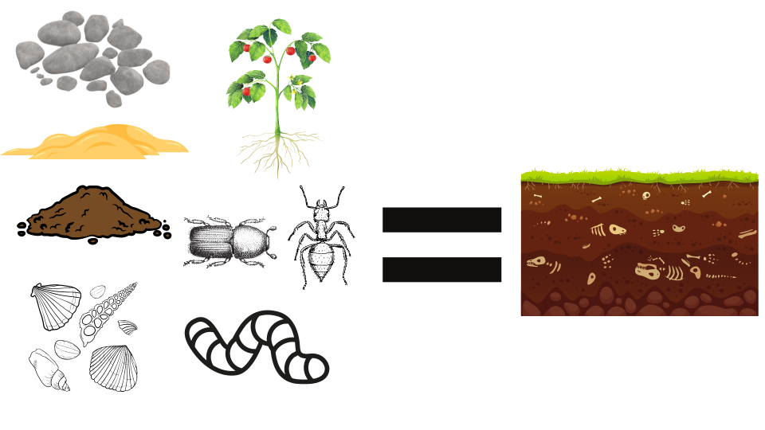
There are living and dead insects and worms. There is even WORM POOP in soil.
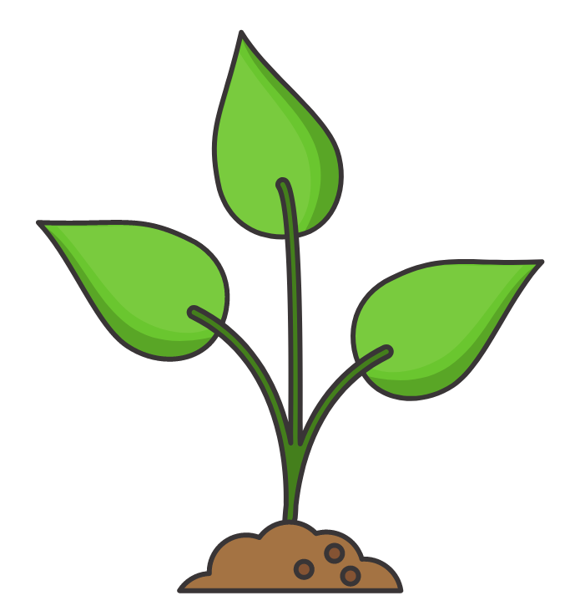

Soil is important for helping plants grow.

Humans and animals eat these plants to survive.

