5th Grade

Sample Science and Literacy Task

Big Idea/ Topic (Science)
Static Electricity

Reading/ Writing Skills
Reading Skill: Visualize images to help understand a text
Writing Skill: Establishing the setting in a non-fiction narrative

Standard Alignment
Science Standard:
S5P2. Obtain, evaluate, and communicate information to investigate electricity. a. Obtain and combine information from multiple sources to explain the difference between naturally occurring electricity (static) and human-harnessed electricity.

ELA Standards:
ELAGSE5RI1
Quote accurately from a text when explaining what the text says explicitly and when drawing inferences from the text.

ELAGSE5W3 Write narratives to develop real or imagined experiences or events using effective technique, descriptive details, and clear event sequences.
a Orient the reader by establishing a situation and introducing a narrator and/or characters; organize an event sequence that unfolds naturally.

Table of Contents
- Teacher instructions for whole group
- Print ready student sheets
- Print ready article to read

Pre-Reading: Static Electricity Investigation
Students will be ready to read when they have observed static electricity as it attracts and repels things, and when they have seen how they can create static electricity by friction. These activities are especially important to give students the background they will need to practice the reading skill.
Note that these activities may be affected by humidity. On extremely humid days, when the air conditioner is not up to the task, they may not work as well.
Materials: 2 balloons (one for each person in the collaborative pair), String – 10 to 12 inches per student, Scraps of wool cloth such as washed felt or an old sweater (make sure if you use an old sweater or some other type of clothing that it has not been washed or dried with any type of static eliminator), Paper Towel, Salt, Pepper, small squares of aluminum foil or empty soda cans
Activity 1: Electric Balloons
Start the investigation by asking: Have you ever touched a doorknob and felt a small shock? Have you ever pulled off a sweater and your hair stood up? Have you ever opened a pack of crackers and the plastic seemed to stick to your hand? Have you ever taken clothes out of the dryer and have a sock or cloth stuck to something else? Why do you think those things happened? Today we are going to see if we can make some similar things happen.
Pair students and give them the directions/ observation page. Lead them through the steps on the observation page. They should see that uncharged balloons do not attract, charging just one balloon causes the balloons to attract, and charging both balloons causes the balloons to repel. You may wish to introduce the words “attract” and “repel” as you discuss this activity.
Activity 2: Balloons and Other Items
Provide students with the additional items listed above and lead them to test charged and uncharged balloons with these items. If students successfully remove all the charge from their balloons, the balloons should not attract salt, pepper, or the aluminum foil/can. If you are having a hard time getting all the charge off, try gently hugging the balloons and patting them all over with your hands or a paper towel.
With the charged balloon, students should be able to hear and see the salt as it is attracted to the balloon. They may have seen the pepper but not heard it due to pepper being lighter than salt. If you use aluminum foil, the foil should “levitate.” If you use an aluminum can, students will be able to roll the can across the table or floor by pulling it forward with the charged balloon.
Extension Activity
Materials: Balloon and wool cloth from Previous investigation, Plastic produce bags from the grocery store
1. Cut the produce bags into 2-inch strips so that when they are opened, they make a circle.
2. Charge the blown-up balloon.
3. Have one partner charge the produce bag on the wool cloth.
4. Have the other partner charge the balloon on a wool cloth.
5. Once both items have a charge. Have the student with the produce bag stand in a chair with the bag strip open so it makes a circle.
6. Have the other student use a balloon under the circle to try to make the circle hover.
This activity is a challenge, but most students can eventually get it to work. The balloon should levitate the produce bag. Some students find that opening the produce bag strip and rubbing in a circular motion makes for better hovering. Some students find that opening the produce bag strip and rubbing in a circular motion makes for better hovering.
Reading: It’s Electric!
Reading Skill: Visualize images to help understand a text
Tell students that they are going to read an article that will explain more about the activities they just completed and how scientists explain what happened with the balloons.
Before reading, tell students “picturing as they read” can help them understand as they read about science. Science texts often describe situations, and if we can make a picture of it in our heads as we read, it helps us understand.
Point students to the first sentence in the text (It’s Electric, link here):
Have you ever grabbed a doorknob and felt a shock?
Tell students that as you read that sentence, you imagine reaching for a doorknob and feeling the shock. Expand a little on what you envision: maybe you picture the doorknob in your classroom, or the door to your room at home. Maybe you are remembering a particular time that you shocked yourself.
Now read the second sentence: Maybe you shook hands with a friend, and she yelled, "Ouch! You shocked me!"
Ask students to make a picture in their mind of that sentence and allow several students to share what they pictured.
Finally, point out the places in the article that have asterisks (or stars). Tell students that when they are reading and reach an asterisk, they should notice what picture they are forming in their minds.
After students have read the article, ask students to share what they visualized for some of the asterisks. Have students to quote what the article said, and to describe what they saw. Point out that much of what we visualize will be inferences, based on what we already know. You may want to point out some ways that students are adding to the information from the text in their visualizations.
Whenever possible, restate the student responses to include the science vocabulary (charges, static, electricity, energy, positive, negative, attract, repel).

Post-Reading: My Experience with Static Electricity

Writing Skill: Establishing the setting for a non-fiction narrative

Writing Prompt:
Describe a time that you experienced Static Electricity. It can be something that happened to you when you were younger, or it could be one of the experiences that you had in class working with the balloons. Describe where you were, what you did, what happened, and the science that explains why it happened. Use at least 4 of the vocabulary words from the word bank.

Before turning students loose to write, remind them that their readers will be trying to picture what is happening, just like they were trying to make pictures as they read the Static Electricity piece. Providing the setting for a narrative is an important part of helping the reader picture the event. Remind students that the setting includes where something happened, when it happened, and what the environment was like. In a short piece like this one, letting the reader know who is present can also help create the scene.

Give students the writing graphic organizer to help them produce their best writing piece.
(Link writing graphic organizer here)
Return to the table of contents

Print Ready Student Sheets

Static Electricity Investigations
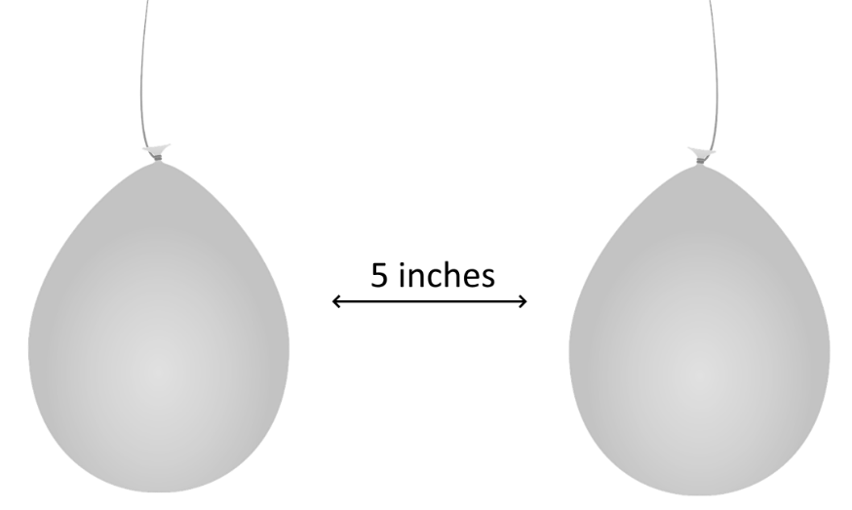
Activity 1: Balloons
1. Blow up two balloons. Tie a string around each one.
2. Hold the balloons about 5 inches apart as shown here:
Describe how your balloons are hanging: _________________________________________
__________________________________________
3. These balloons do not have an electric charge. You can give them a charge by rubbing them with the wool cloth. Rub just one balloon with a wool cloth.
4. Hang them upside down again, about 5 inches apart. Draw what happens in the space below:

5. Now rub both balloons with the wool cloth. Hang them upside down and 5 inches apart. Draw what happens this time.
Activity 2: Balloons and Other Items
1. Rub both balloons all over with a paper towel. This will take the charge off the balloons.
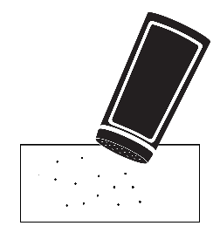
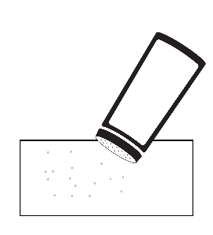
2. Pour a small amount of salt on a piece of paper towel, and a small amount of pepper on another paper towel. Put the soda can or a piece of aluminum foil next to the paper towels, as shown below:

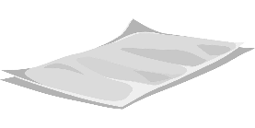

3. Hold one uncharged balloon a few inches over each item, one at a time. Describe what you see in the chart below and circle if the item is attracted to the balloon.
4. Charge a balloon by rubbing it with the wool cloth. Again, hold it over each item. Fill in the second line of the chart.
 | salt | pepper | Aluminum foil  or soda can
Uncharged Balloon | attracted/ not attracted | attracted/ not attracted | attracted/ not attracted
Charged Balloon | attracted/ not attracted | attracted/ not attracted | attracted/ not attracted
5. Repeat step 4 and listen carefully. Do you hear anything? If so, describe it.________________
______________________________________________________________________________
My Static Electricity Experience

Describe a time that you experienced Static Electricity. It could be something that happened to you when you were younger, or it could be one of the experiences that you had with balloons in class. Use at least 4 of the vocabulary words from the word bank.
WORD BANK
Energy Electricity Static Charge Negative Positive Attract Repel
Setting
In this box, describe your setting. Remember that it should help your readers picture the story in their heads!

Static Electricity Event
In this box describe what happened.

Why It Happened
In this box, explain the science behind what happened (be sure to use your vocabulary!)

Conclusion
In this box write a conclusion sentence for your story.

Print Ready Article

Reading Skill: Picturing as you read
Each time you see a star (*), make a picture in your imagination of what you are reading!
It’s Electric!
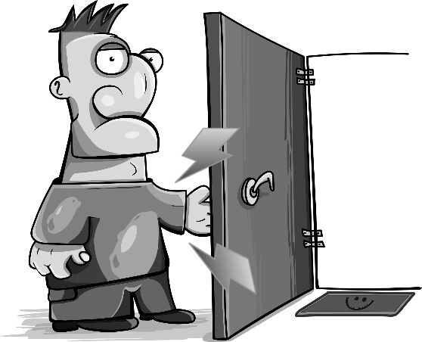
Have you ever grabbed a doorknob and felt a shock? Maybe you shook hands with a friend and she yelled, "Ouch! You shocked me!" When you feel a shock, it hurts, because energy is surging into your body. That energy is called electricity.
Electricity is made of moving charges. There are positive charges and negative charges. You may have heard it said that "opposites attract." That's certainly true for negative and positive charges! Whenever they can, negative charges race toward positive charges.
All Charged Up
Picture yourself rubbing a balloon with a wool cloth.* That process causes negative charges to build up on the balloon. If you put that balloon near another object, the negative charges move from the balloon to the object, creating a little burst of electricity.* The electricity can pick up tiny objects, such as pepper or bits of paper.*
The opposite of "opposites attract" is also true. If two objects have the same charge, they repel each other, which means they push each other away. If you rub two balloons with wool cloth, they will both have a negative charge. They will move apart.*
Shocking!
Shocks from a doorknob and charged balloons are two examples of static electricity. Static electricity is the name we give to electricity that happens naturally.
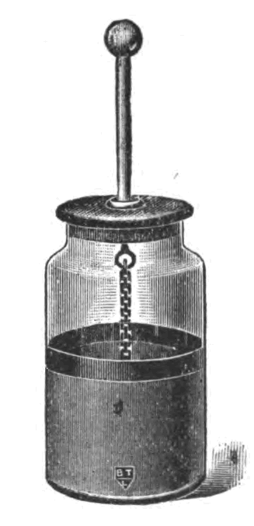
In the 1600 and 1700's, scientists realized that static electricity could be stored and used later. They created objects called Leyden jars that worked something like a battery.
Leyden Jar
They would rub cloth on a metal knob, much like you did with the balloon.* The jars would develop a strong negative charge. When the scientists wanted to release the charge, they would touch a wire to the jar, and the electricity would race into the wire. Often, they would be able to see a spark.*
Kite in the Night
In the late 1700's, Benjamin Franklin wondered what lightning was made of. He thought it might be made of powerful bursts of static electricity. He came up with a clever test to find out.
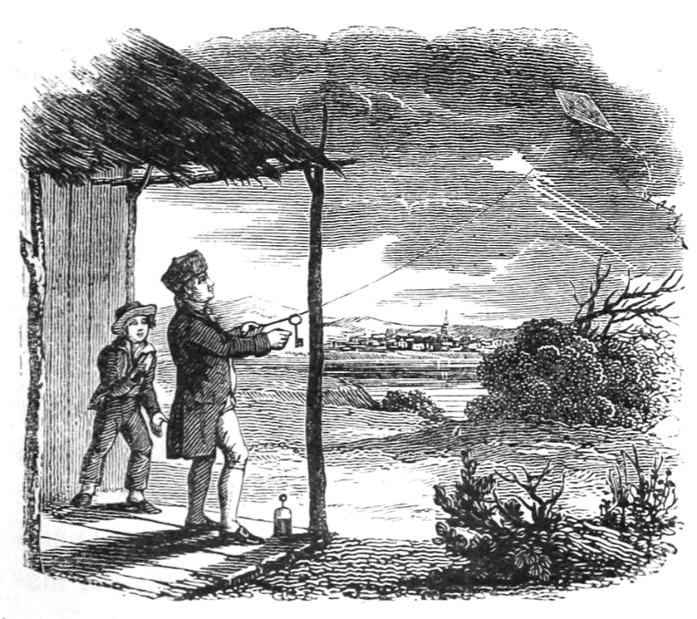
He fastened a piece of wire to a kite to attract electricity. Then he tied a rope made of two parts. One part was wet and would carry electricity. The other he kept dry so that his hands would not get shocked. He tied a key to the wet part of the rope.
Then he did something daring, or perhaps stupid. He flew the kite during a thunderstorm! Lightning flashed near the kite. Zip! Zap! Electricity raced into the wire, down the kite rope, and into the key.* Benjamin Franklin held his hand near the key and felt a shock.* He even managed to trap some of the electricity in a Leyden jar. He was lucky he didn't get killed by the intense energy in lightning!
However, his experiment worked. It showed that lightning is also a type of static electricity.

Image Information and Permissions

The Leyden jar image comes from Wikimedia commons and is in the public domain: https://commons.wikimedia.org/wiki/File:Leyden_jar_engraving.png?uselang=en#Licensing
Ben Franklin’s Kite experiment is also in the public domain and comes from Wikimedia Commons: https://commons.wikimedia.org/wiki/File:Dr._Franklin%E2%80%99s_Kite.png.
All other images were created from public domain images provided on pixabay.com.

