Keeping Hold of the Best Dirt in Georgia
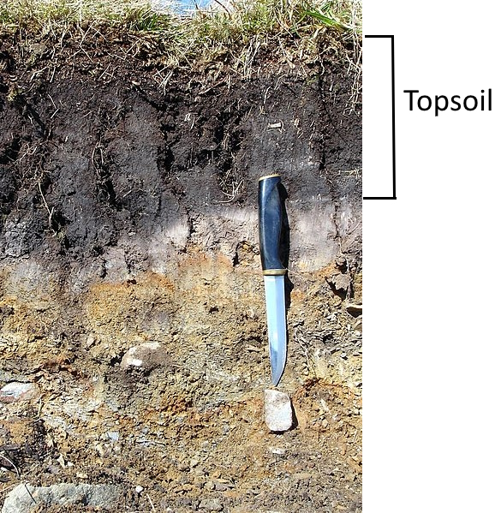
Dirt may just seem like dirt. But dirt, which scientists call soil, is a mixture. It has minerals, rock, and bits of dead plants, animals, and other organisms. Those dead bits are called organic matter, and organic matter is important. Organic matter contains many nutrients that plants need to grow.

Organic matter is mostly found in the top few inches of soil. This nutrient-rich dirt is called topsoil. Below the topsoil, the dirt is packed more tightly and has fewer nutrients. In much of Georgia, the dirt below the topsoil is heavy red clay, which is especially difficult for plant roots to penetrate. For this reason, keeping the topsoil intact is critical for everything from agriculture to lawns.

Losing Topsoil
The main cause of topsoil loss is rain. During heavy rains, water races across the ground. Topsoil is loose and easily swept up in the flow. When the earth is worn away by water or other forces, it is called erosion.

Water always runs downhill. This means that once water has made a track in the dirt, more water is likely to run into that same track. The rut gets deeper and deeper with each rainstorm. Soon, the erosion can be seen easily by anyone walking past.
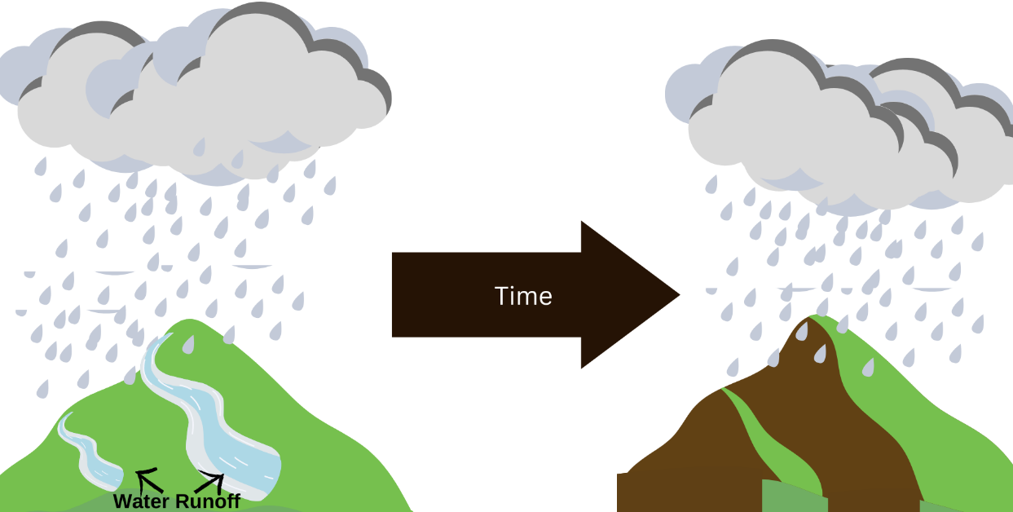

When the water finally slows down, it dumps the topsoil it has been carrying. The soil may end up in a river. Too much soil dumped suddenly can make it difficult for fish to breathe. The soil may end up in a pond or lake. Over time, so much soil may end up in a pond or lake that it fills in and creates marshland.
Saving Topsoil
Georgians want to stop erosion and keep the topsoil in place. One solution is to make sure there are plants in the topsoil. Plant roots trap the soil, so it is harder for it to wash away. They also serve as a barrier to slow down the water. Slower water has less energy and picks up less soil. As the water slows, it also drops the soil it has been carrying.
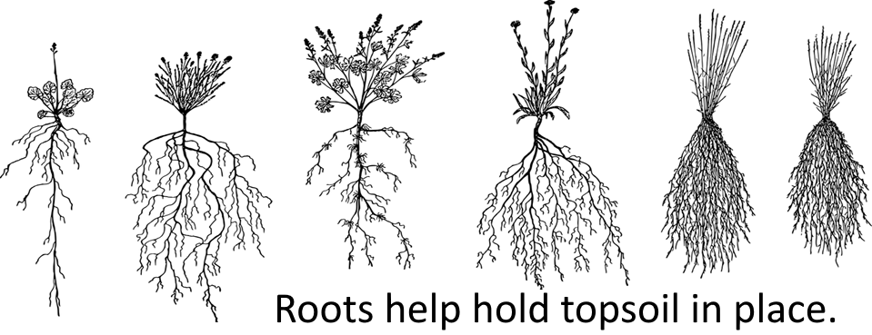
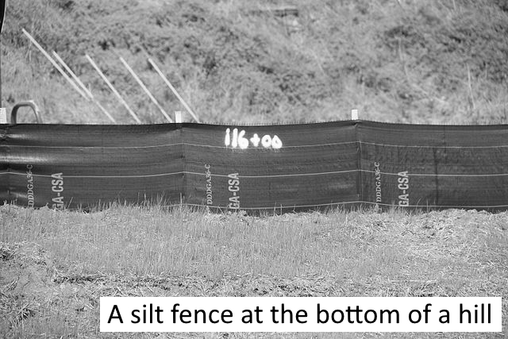
People use other types of barriers to prevent erosion as well. People may place logs or rocks along hillsides that are starting to erode. Sometimes retaining walls are used to slow the flow of water. At construction sites, there is often black cloth hung between sticks. This is called silt fencing, and it helps keep water from carrying away the dirt that has been stirred up by construction.

Erosion is a natural process. It can be destructive when it removes topsoil and tears up a hillside. It can be constructive when it dumps dirt in a new place and creates a new marshland. However, sometimes these changes to the Earth cause problems for people, such as the loss of topsoil. Georgians can use plants and barriers to help control erosion so that Georgia will have topsoil for the future.

