Energy in the Leaf Litter

The forest floor is ankle deep with leaves. It looks dead and uninteresting. But in fact, this leaf litter is the basis of an entire ecosystem.

In every ecosystem, a community of organisms and nonliving things interact to pass energy along. In the forest, fallen leaves are a rich source of energy.

Food Chains
Like all plants, trees are producers. They capture energy from the sun and turn it into sugars. Some sugar is stored in the leaves of the plant. When the leaves fall off in autumn, the sugar provides food for all kinds of organisms.

One such organism is the snail. A snail may nibble a leaf, taking the energy into its own body. Then a centipede may eat the snail, taking the energy another step.

Scientists refer to this as a food chain. Food chains are the order, or sequence, of what organisms consume, often beginning with the sun’s transfer of energy. They show the movement of energy with arrows, as seen in the diagram below.
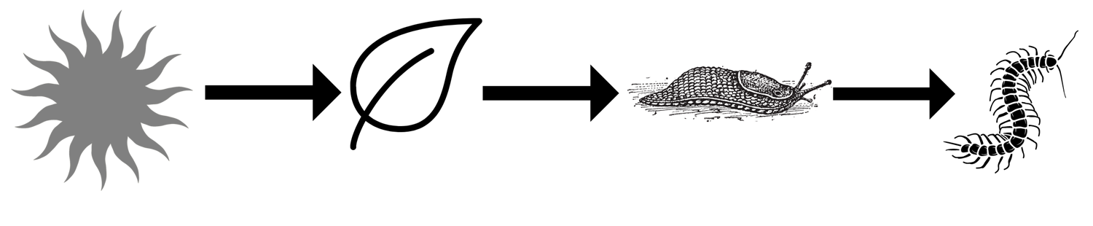
Diagram 1: A short Food Chain

Food Webs
Of course, real life is more complicated than one food chain shows. That snail may also eat a fungus that is growing on the leaf. A hammerhead worm may hunt the snail. In this case, the hammerhead worm and the centipede compete for the same source of energy.

When many organisms compete in the same ecosystem for food, their food chains overlap. The overlapping food chains create a food web, as shown in the diagram below.

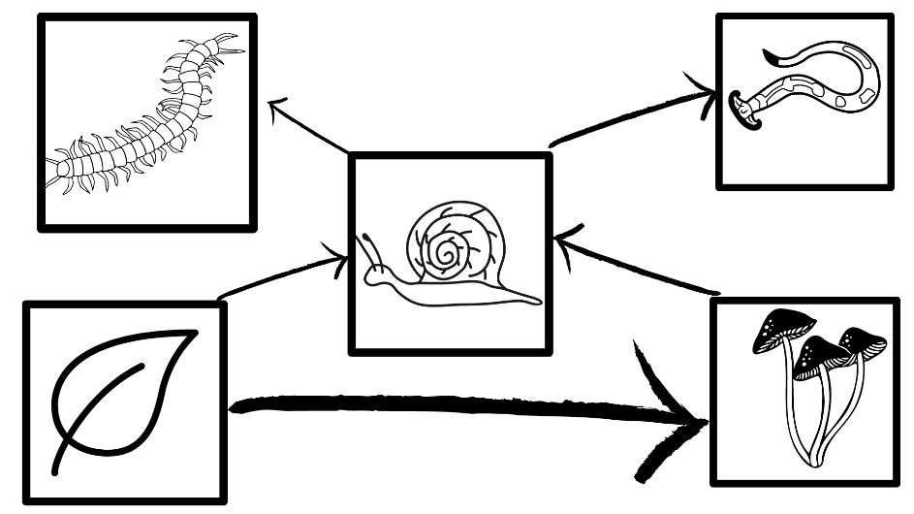
Diagram 2: A small food web

Roles in a Food Web
Scientists sometimes sort organisms based on where they fall in a food web. Producers are at the bottom of the food chain. Most producers are plants. They make their own food from sunlight.

Consumers come next. Some consumers get all of their energy from leaves and plants. In the leaf litter, this includes earthworms, snails, slugs, pillbugs, crickets, and millipedes. Scientists call these consumers herbivores.

Other consumers get some energy from plants, but also eat other consumers. Ants, for example, may eat leaves, fungus, or other insects. Earwigs often eat leaves and fungus, but also eat small insects like ants and springtails. Organisms that eat both plants and other organisms are called omnivores.

Finally, there are the consumers who always eat other consumers. Spiders capture crickets, ants, and small beetles. Centipedes chow down on earthworms, crickets, and pillbugs. Hammerhead worms slurp up snails, slugs, and earthworms. These consumers are called carnivores.

All of the organisms in a food web eventually pass energy to the decomposers. Decomposers live in and on dead plants and animals to digest them. Fungi are one kind of decomposer. You may recognize some kinds of fungi, such as mushrooms. But fungi can also look like powders, or even tiny threads, growing on a dead leaf. Bacteria are also decomposers. Bacteria are too small to see, but sometimes they create a slimy layer that you can feel.

Even in a Pile of Leaves
In any ecosystem, energy moves through food chains and food webs. This energy allows living things to maintain daily functions, such as growth, movement, and reproduction. Food chains and webs exist even in places as unlikely as a pile of leaves on the forest floor.

