Cloud images for Pre-Reading (only use if LIVE observation isn’t possible)
 | Day 1  74° 46°  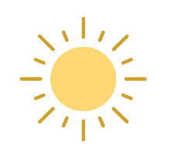  Mostly sunny  0% chance rain
 | Day 2  76° 36°  Mostly sunny  0% chance of rain
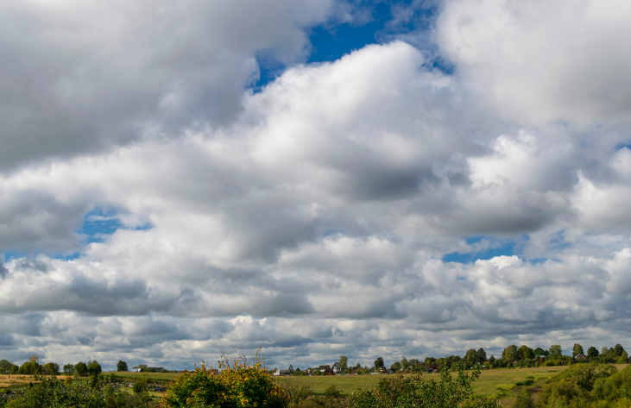 | Day 3  73° 36°  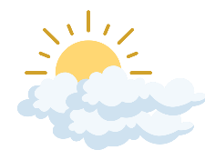  Partly cloudy  10 % chance of rain overnight

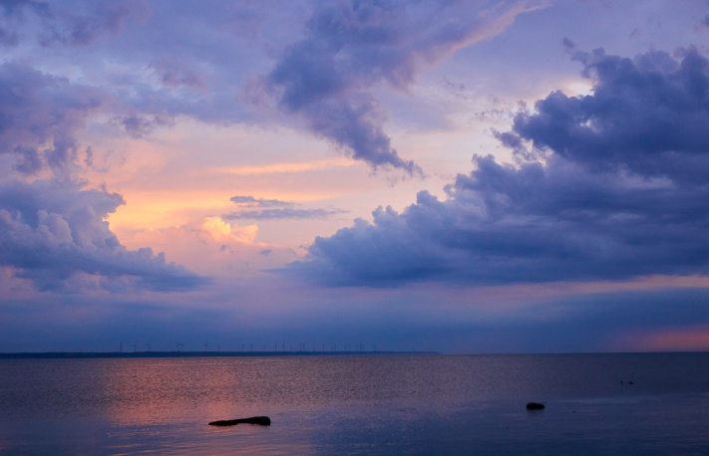 | Day 4  66° 30°  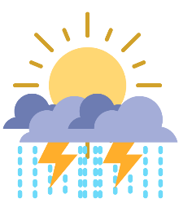  Thunderstorms likely late evening  50% chain of rain
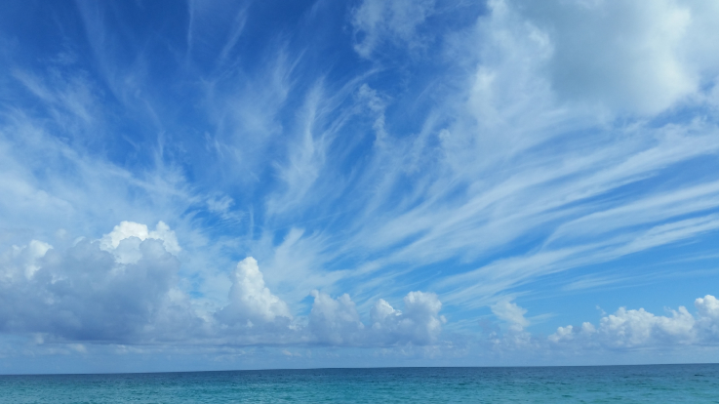 | Day 5  73° 36°  Mostly sunny  0% chance of rain
 | Day 6  70° 35°  Partly cloudy  0% chance of rain

