Sources of Heat
Heat is a type of energy. We get heat from a variety of sources. That heat energy can then move from one place to another.
Heat Sources
The biggest source of heat for the Earth is the sun. The sun is a burning ball of gas. The fire creates a lot of heat. The heat travels throughout the solar system. If it were not for the sun, the surface of the Earth would be too cold for humans. The sun is an example of a natural heat source.
Lightning is another natural heat source. The electricity in a flash of lightning has so much energy that it can start fires. Lightning heats the air as it moves through. The hot air moves quickly, creating the loud sound that we call thunder.

Of course, fires are a source of heat. Wood and other fuels have stored energy. When a fire starts, that energy is released as heat. When a fuel has lots of stored energy, it burns very hot and for a long time. Fuel that has less energy does not get as hot when it burns and will not last as long.
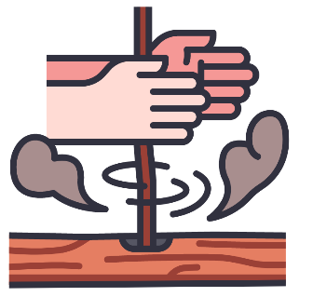
Some fires happen in nature. Others are created by humans. People use fires to make things. We cook our food. We melt metal to make new objects. We also use fire to keep ourselves warm.
Humans make heat in other ways, too. Electricity powers heaters, stoves, irons, and other sources of heat.
We can also make heat by rubbing things together, in a process called friction. If you rub your hands together, you can feel them get warmer. People can even start fires by rubbing the right kinds of rocks or sticks together to create sparks of heat energy.
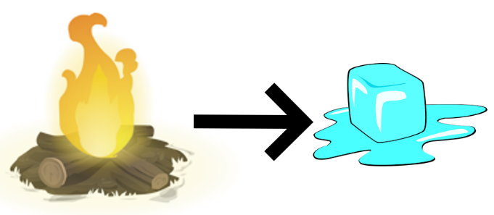
Heat on the Move
Heat energy moves. Heat energy moves from warmer places into colder places. You can see this with an ice cube. Once an ice cube is out the freezer, the air around it is warmer than it is. The heat from the air moves into the ice cube and the ice melts.

Heat energy tends to move up. Both hot air and hot liquid float to the top of cooler air or cooler liquid. For example, the basement of a building often feels cooler than the rest of the building. In winter, the basement may be too cold. But in the summer, going down into a basement can feel just right.

Reading Skill: Asking and Answering Questions
Use the article to help you answer your own questions about heat. Pick three questions about heat from your investigations. Write the questions below. For each one, write the answer and underline where you found the answer in the text.
      - ___________________________________________________________________________________________________________________________________________________________________________________________________________________________________________________
      - ___________________________________________________________________________________________________________________________________________________________________________________________________________________________________________________
      - ___________________________________________________________________________________________________________________________________________________________________________________________________________________________________________________

