

Star Light, Star Bright

​ When we look at the night sky, most of the stars we see look like tiny white lights. When we look at the sky during the day, we see a star that looks much bigger and brighter. It is the Sun! When we look at the Sun at sunrise and sunset, we can often see its yellow color. What we see with our eyes does not tell us the whole story, however.

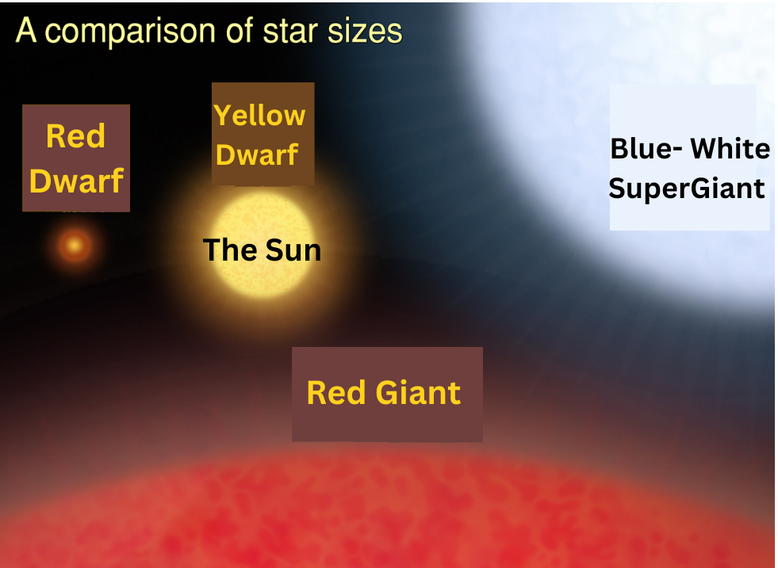
Stars are burning balls of gas. The burning gases create light that travels across the galaxy. Stars come in many colors and sizes. In general, bigger stars create more light.
Attribution: Original image by ESA/Hubble (M. Kornmesser), labels edited by GaDOE shared under a Creative Commons Attribution 4.0 International license

The Sun is 93 million miles away from Earth. Even though this is really far, the Sun is still closer to Earth than most stars. The next closest stars are 24 trillion miles farther away than the Sun!

Many stars are much bigger and brighter than the Sun. For example, one of our closest stars is called Alpha Centauri A. It is bigger than the Sun and almost two times as bright. It looks tiny and less bright because it is so far away. It is also orange, like the Sun. But it is too far away for people on Earth to see the color without using a telescope.

Next time you look at the night sky, remember that those tiny white stars may be bigger and brighter than the Sun.

