HOW DOES SOUND WORK?

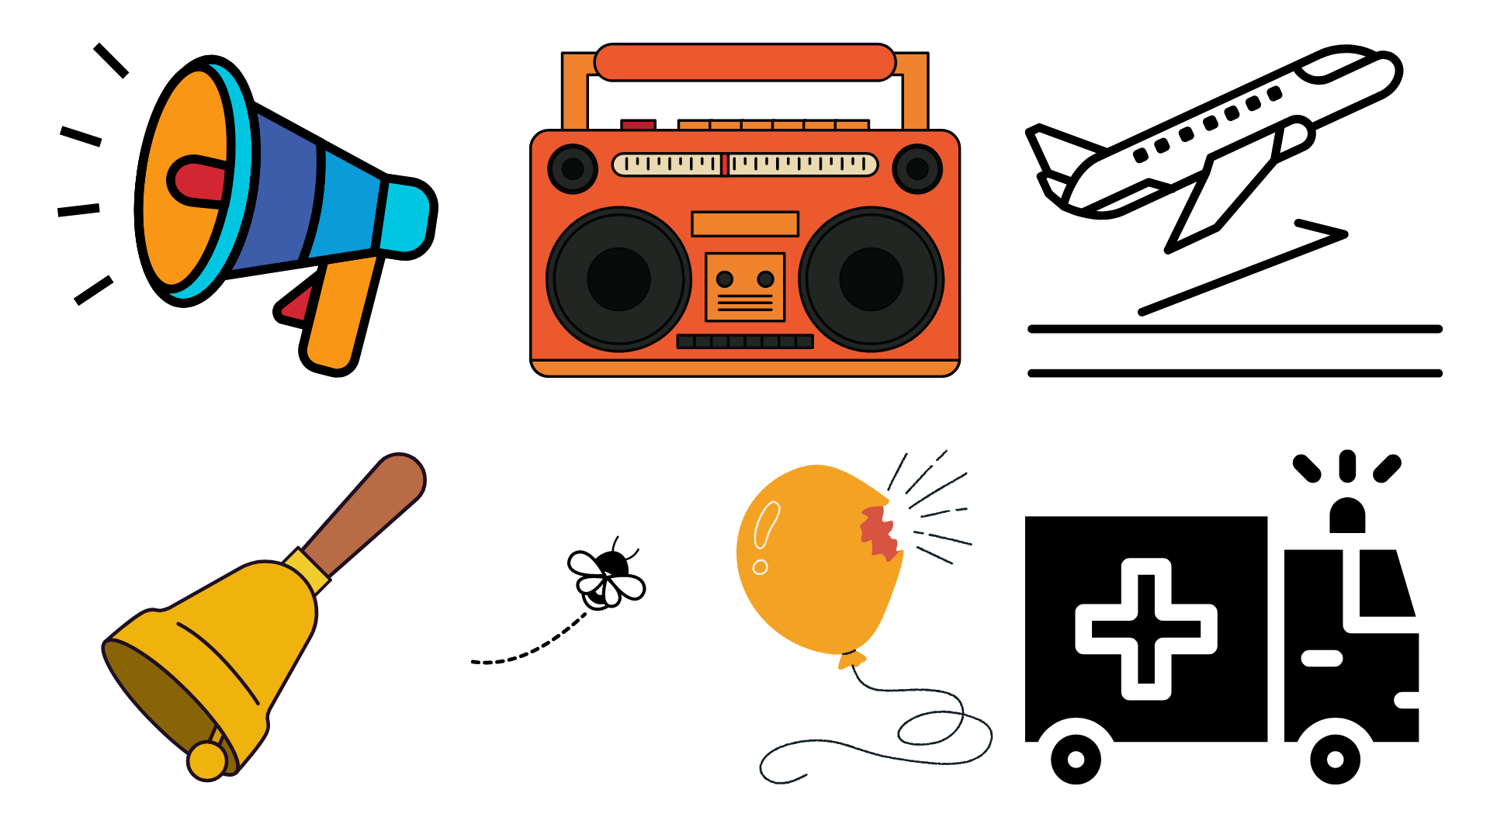

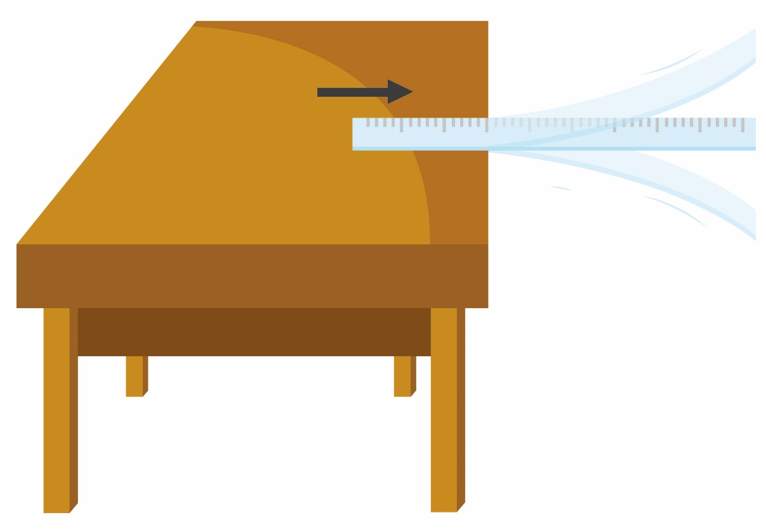
Attribution: Honourr, Sound Vibration Experiment Ruler Stock Vector (Royalty Free) 2103956891 | Shutterstock

Sound is made when an object vibrates. To vibrate is to move quickly back and forth.

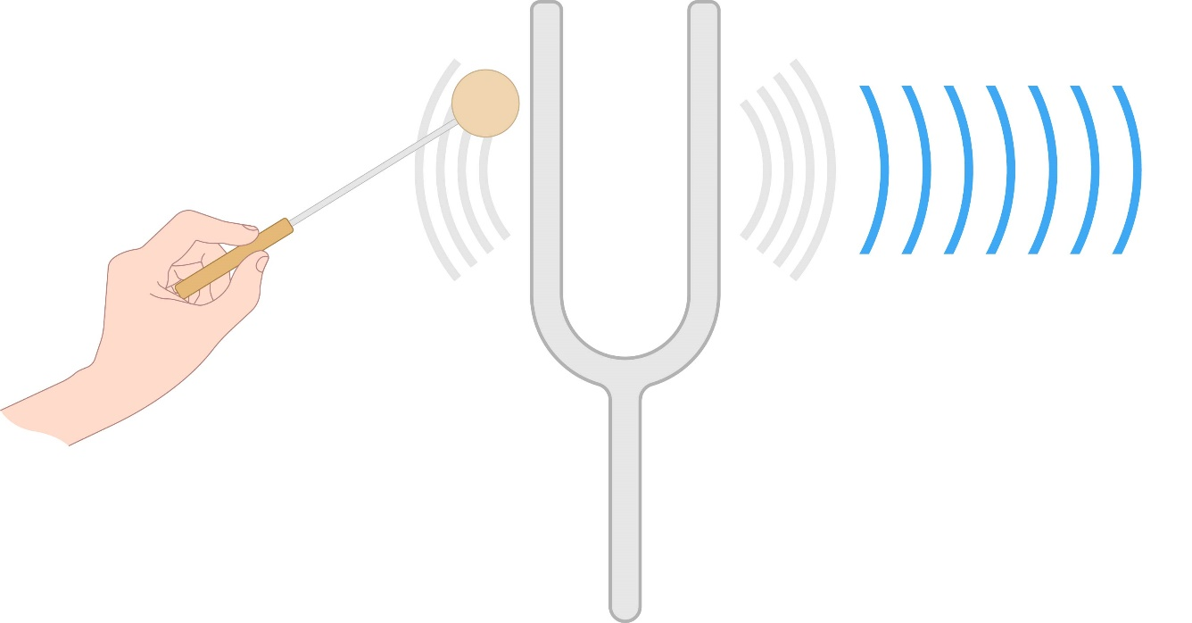
Attribution: Pepermpron, Scientific Experimental Tuning Fork Generate Sound Stock Vector (Royalty Free) 2169347303 | Shutterstock

Vibrations move through air, water, and solid objects. We call moving vibrations “sound waves.”



The strings on a guitar vibrate and make sounds when you pluck them.



The top of a drum vibrates and makes a sound when you hit it.
When the sound waves reach our ears, they make our eardrum vibrate. Then our brain hears the sounds.

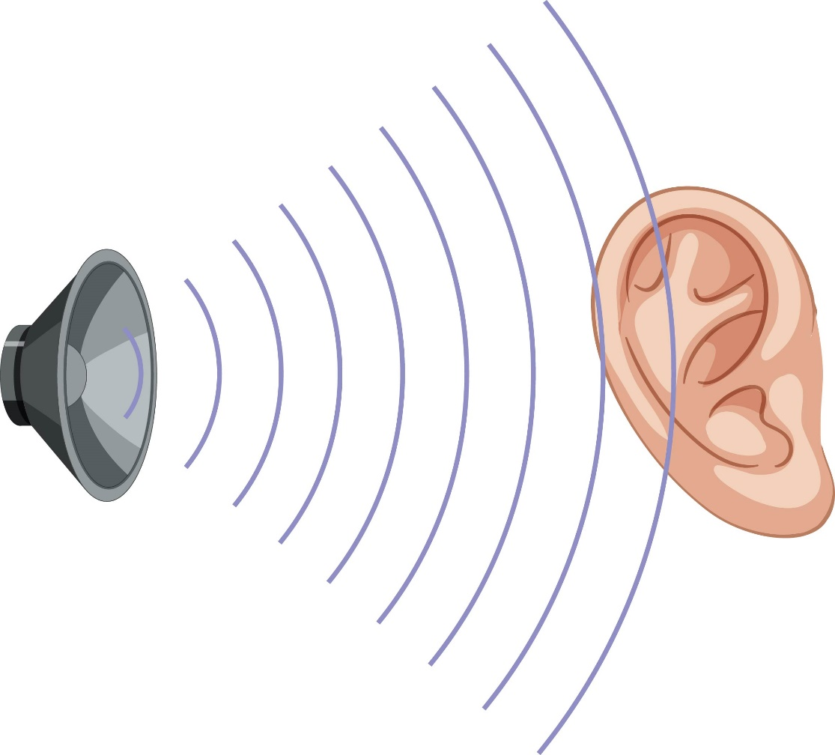
Attribution: BlueRingMedia, Speaker Icon Ear On White Background Stock Vector (Royalty Free) 2143503325 | Shutterstock

Big vibrations make loud sounds.

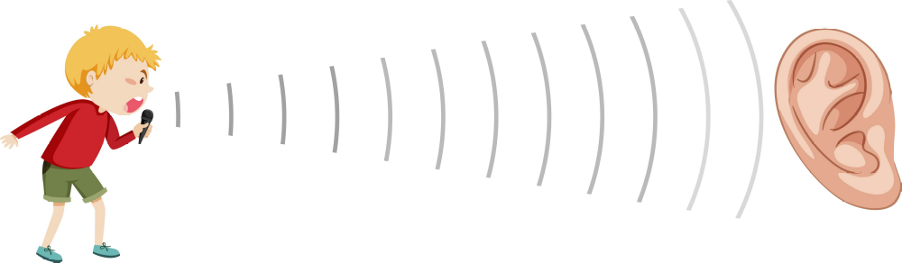

Attribution: BlueRIngMedia, Boy Singing Sound Wave Icon Illustration Stock Vector (Royalty Free) 2148126083 | Shutterstock

Small vibrations make quiet sounds.

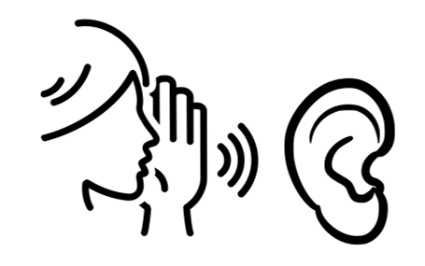

Sound waves can also make objects vibrate.
Have you ever felt yourself vibrate when you got close to a very loud speaker?



