Elephant Power
An elephant trunk can hoist a massive tree trunk. It can also lift a delicate tortilla chip without breaking it. It can accomplish these tasks even though it has no bones inside to give it structure. Andrew Schulz, a researcher at Georgia Tech, is using physics and math to find out the secrets of the elephant’s lifting power.
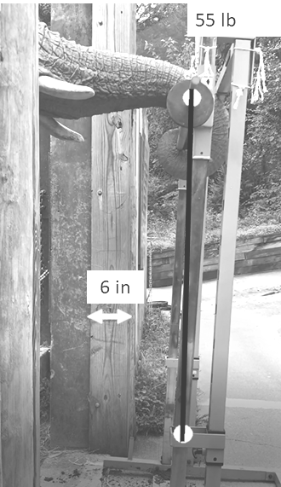
This elephant can lift a 55 lb. weight by wrapping his trunk around the barbell. Using the information in the photograph, calculate how high (in inches) he was able to lift the weight.
(Hint: how long is the line between the white dots, if the width of the arrow is 6 inches?)

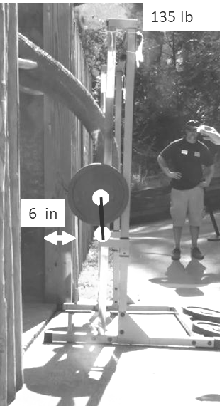
The elephant can lift a 135 lb. weight, but not as far. Using the information in the photograph, calculate how high he was able to lift 135 lbs.

Using your data from above, figure out weight at which the elephant could no longer lift the barbell. (Hint: What weight does the elephant lift 0 inches? Try using a graph!)

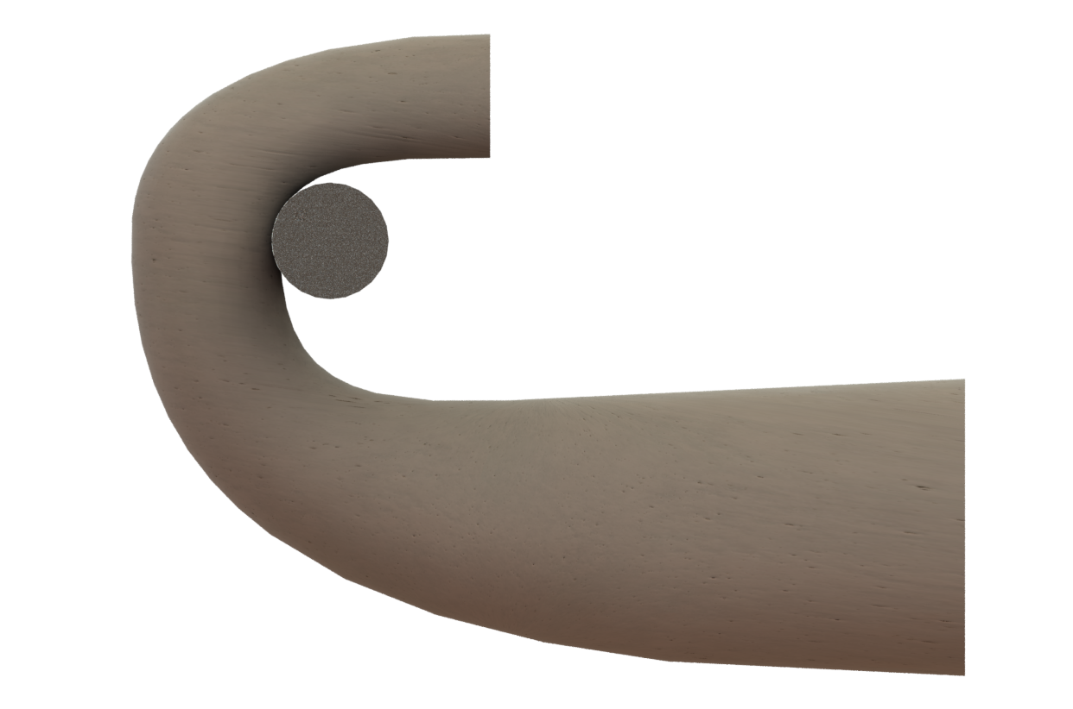
Forces on an Elephant’s Trunk
$$a$$
$$g$$
F
$$θ$$
x
y
$$m$$
Figure 1 shows the forces on an elephant’s trunk when it lifts a barbell.
1) Use the vertical forces to find an equation for the lifting force.

2. What is the force (F) when the elephant lifts 20 kg. with acceleration $2.0\frac{m}{s^{2}}$ and an angle of 30 degrees?
Figure 1. Forces on elephant lifting a barbell

3. What is the force (F) when the elephant lifts 60 kg with acceleration of $0.5\frac{m}{s^{2}}$ and angle of 85 degrees.

4. What is the maximum power the elephant can lift the 20 kg barbell from question 2, with a velocity = 5 m/s?
(Hint: Power = Force*Velocity)

4. What is the maximum power the elephant can lift the 60 kg barbell from question 3, with a velocity = 3 m/s?

5. Why does the power of the elephant decrease when the weight increases?

